Key: **# = Sharp**

***b* = Flat**

♮ = Natural

Redden Court School

[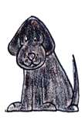](http://search.live.com/images/results.aspx?q=black+dog&form=QBIR#focal=8ce3183375fd3e2f766679604421a351&furl=http://www.tlcbytara.com/DesignLibrary/Animals/Brown_Black_Dog.gif)

Year 8 Keyboard Layout

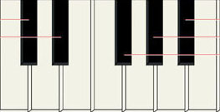

**C#/D*b***

**F#/G*b***

**G#/A*b***

**D#/E*b***

**A#/B*b***

[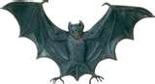](http://search.live.com/images/results.aspx?q=bat&form=QBIR#focal=af205e6445647b5d0c51e46c575d6bd3&furl=http://ingham.org/AC/picts/BAT.jpg)

[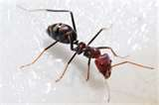](http://search.live.com/images/results.aspx?q=ant&form=QBIR#focal=bee156e1faa5039bee405d7df81d53b6&furl=http://blog.makezine.com/800px-Meat_eater_ant_feeding_on_honey02.jpg)

[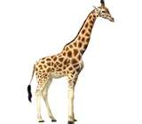](http://search.live.com/images/results.aspx?q=giraffe&form=QBIR#focal=008efe53eb61be364dcb7e22b71abc1e&furl=http://www.giraffes.org/giraffe-pic.jpg)

[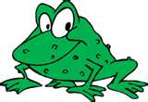](http://search.live.com/images/results.aspx?q=frog&form=QBID#focal=9ab5a4d5fac2a7b25974145e986714f8&furl=http://teacherexchange.mde.k12.ms.us/teachnett/images/frog.jpg)

[](http://search.live.com/images/results.aspx?q=elephant&form=QBIR#focal=1162750bdf048c9bfbd4479eab15c8c3&furl=http://www.randomgames.net/games/snapp_animals/extras/cartoon_elephant_caricature.png)

[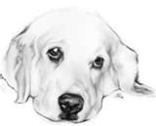](http://search.live.com/images/results.aspx?q=white+dog&FORM=BIRE#focal=eecf84aded4ced0ee6a8216419b5a8db&furl=http://www.samithorpe.co.uk/images/pic-dog01.jpg)

[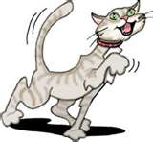](http://search.live.com/images/results.aspx?q=cat&FORM=BIRE#focal=4e35b357c49d0570b86d292a0e4723b1&furl=http://www.pet-toons.com/images/cat-main-page.jpg)

